**SEVERE WEATHER EVENTS –** **INVESTMENT IN EXISTING WATER SUPPLY INFRASTRACTURE**

In Operation – Yokohama and Istanbul

**SEVERE WEATHER EVENTS –** **STORM WATER MANAGEMENT**

Implementation – Lagos, Columbus, Indianapolis, Kisumu

Operation – Singapore

Scoping – Barcelona

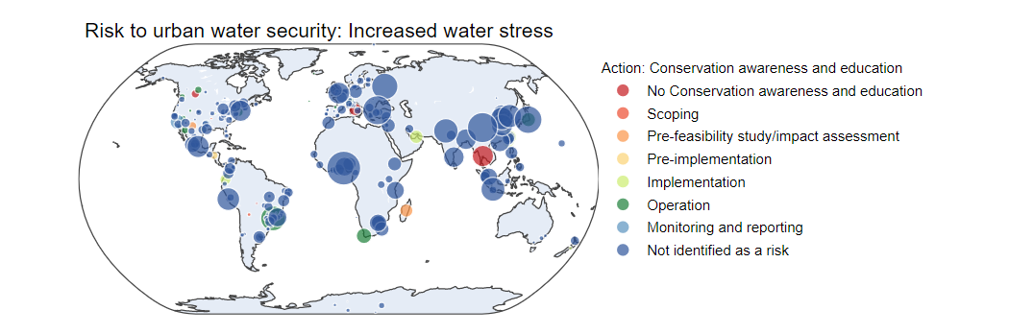

**INCREASED WATER STRESS -** **CONSERVATION AND AWARENESS and EDUCATION**

No Conservation Awareness Education – Bangkok, Roma, Calgary

Pre Feasibility/Pre implementation – Antananarivo, Tegucigalpa, Juarez Mexico

Operation/Implementation – Cape Town, Dubai, Sao Paulo Brazil, Hermosillo Mexico, Edmonton Canada

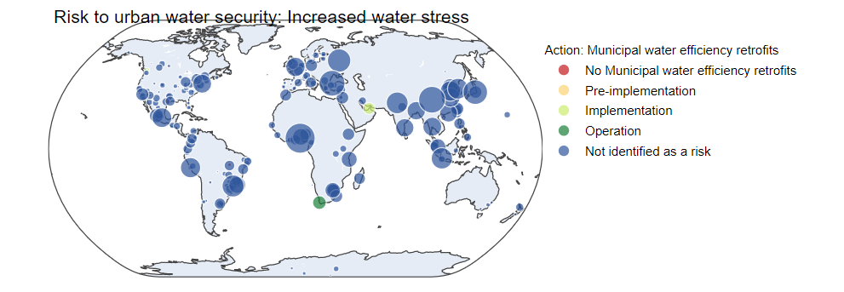

**INCREASED WATER STRESS -** **MUNICIPAL WATER EFFICIENCY RETROFITS**

Implementation/Operation – Dubai and Cape Town

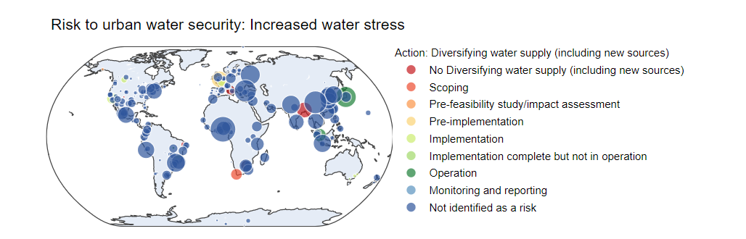

**INCREASED WATER STRESS -** **DIVERSIFYING WATER SUPPLY**

No Diversifying Water Supply – Dhaka Bangladesh, Roma, Cape Town

Pre Feasibility/Pre implementation – London UK, Anchorage US

Operation/Implementation – Tokyo, Singapore, Calgary, LA

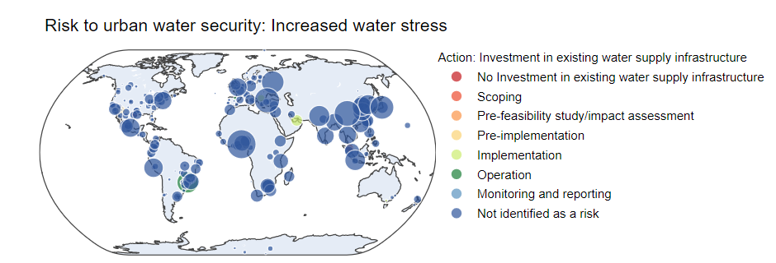

**INCREASED WATER STRESS -** **INVESTMENT IN EXISTING WATER SUPPLY INFRASTRACTURE**

Operation/Implementation – Dubai, Sao Paulo Brazil

**INCREASED WATER STRESS -** **USE OF NON-POTABLE WATER OUTSIDE**

Operation/Implementation – Tokyo, Cape Town, Amman Jordan, Dubai

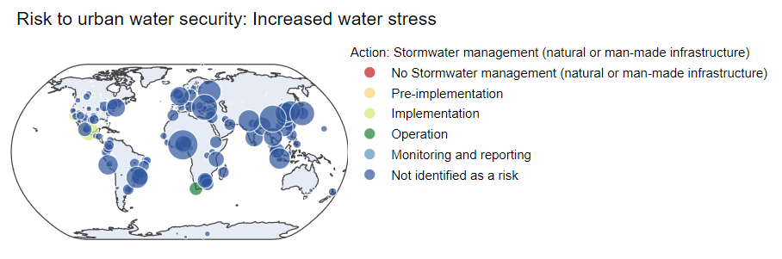

**INCREASED WATER STRESS -** **USE OF NON-POTABLE WATER OUTSIDE**

Operation/Implementation – LA, Mexico City, Cape Town

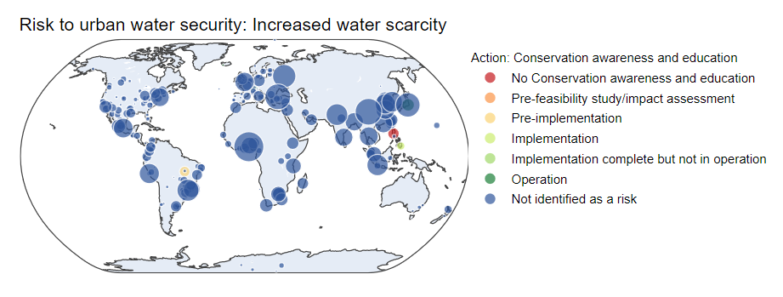

**INCREASED WATER SCARCITY –** **CONSERVATION AWARENESS AND EDUCATION**

No Conservation awareness and education – Quezon City PH

Pre Feasibility/Pre implementation – Davao PH, Fortaleza Brazil